1. **Create a github repository and copy repo URL**

Create a github repository and copy repo URL

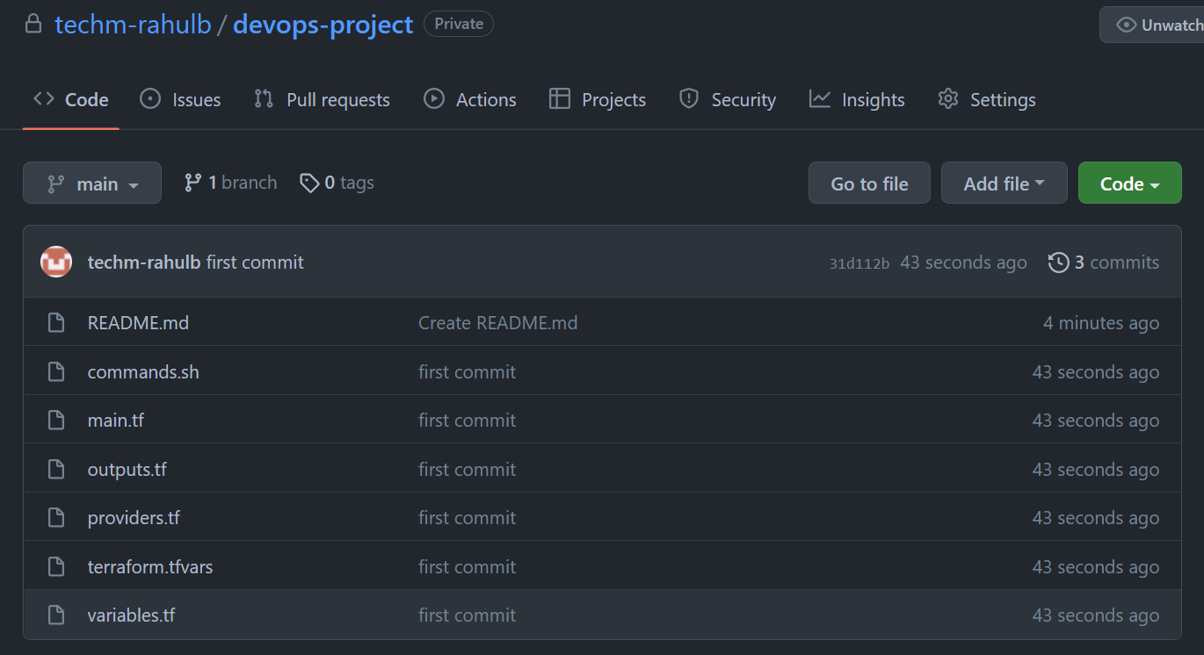

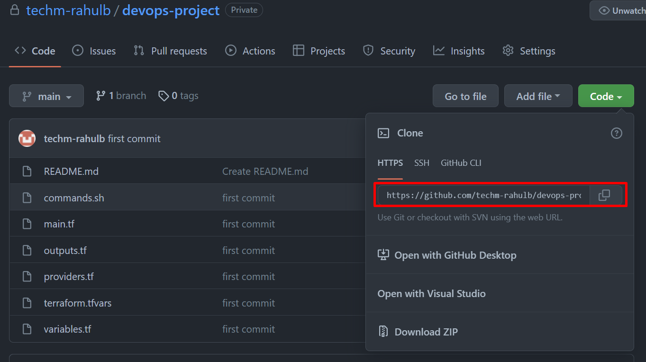

Repo URL :- <https://github.com/techm-rahulb/devops-project.git> ( this is Private repository )